03.04.2025

Krzysztof Smykla

**Lab 2 Report**

**Problem 1 – Discrete Time Signal:**

*Generate the discrete function*

y[n] = 1.90 * y[n - 1] – y[n - 2]

*Plot the result (using the stem() command) with the initial conditions y[1] = 1 and y[0] = 0.*

**Solution:**

I generated the discrete signal using the difference equation   
y[n] = 1.90 * y[n - 1] – y[n – 2], which works by recursively calculating the values of function y.

Plotting the equation generates the following graph:

Fig. 1

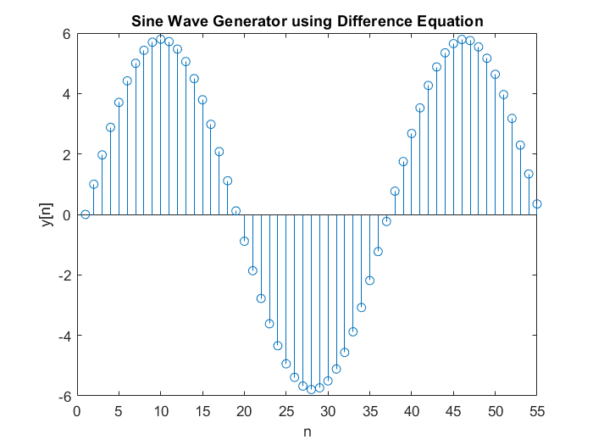

**MATLAB Code:**

% A1.2

% y[n] = 1.90*y[n-1]-y[n-2]

clc, clearvars

y = [0, 1, zeros(1, 98)];

for n = 3:100

y(n) = 1.90*y(n-1) - y(n-2);

end

figure(2)

stem(1:100, y);

xlabel('n') % Label for x-axis

ylabel('y[n]') % Label for y-axis

title('Sine Wave Generator using Difference Equation')

axis([0,55,-6, 6])

**Problem 2 - Feedback System:**

*The response y[n] is fed back through two delays and gains b and c and combined with the excitation x[n].*

*Use MATLAB to generate discrete feedback systems with different parameters a, b and c, plot results.*

**Solution:**

In Task 2, we write a MATLAB script to generate the response y[n] for the second-order system based on the block diagram below.

Fig. 2



The block diagram describes the following second-order difference equation:

y[n] = a*x[n] – a*b*y[n-1] – a*c * y[n-2] (1)

The following plots are then generated on separate figures in MATLAB:

Fig. 2

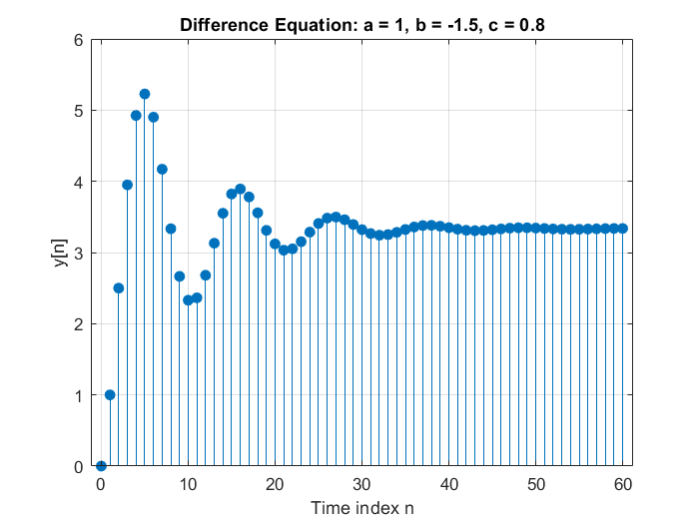

*Coefficients:* a = 1; b = -1.5; c = 0.8

Fig. 3

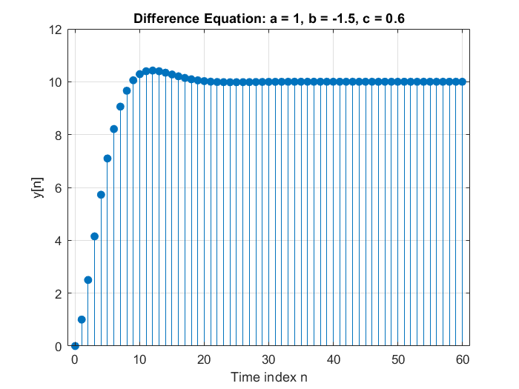

*Coefficients:* a = 1; b = -1.5; c = 0.6

Fig. 4

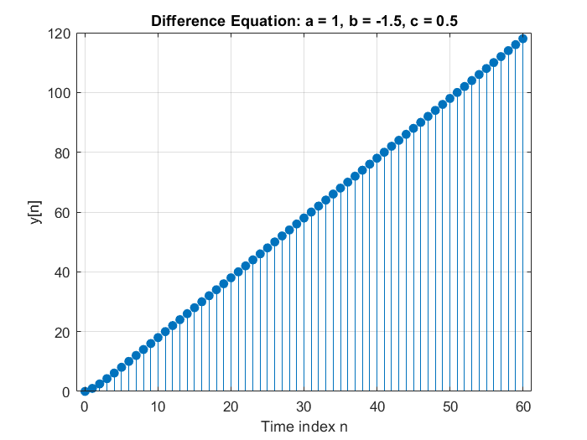

*Coefficients:* a = 1; b = -1.5; c = 0.5

The plots above are generated by the following MATLAB code.

**MATLAB code:**

 % The system described in the block diagram is described by the following

% difference eqation

% y[n] = a*x[n] – a*b*y[n−1] – a*c*y[n−2]

% Defining parameters

n = 0:60;

y = [0 ones(1, length(n)-1)]; % First value is 0, rest are ones

x = ones(1, length(n));

% V1

a = 1;

b = -1.5;

c = 0.8;

for k = 3:length(n)

y(k) = a*x(k) - a*b*y(k-1) - a*c*y(k-2); % corrected equation based on diagram

end

% Plot

figure(1)

stem(n, y, 'filled');

title(['Difference Equation: a = ', num2str(a), ', b = ', num2str(b), ', c = ', num2str(c),]);

xlabel('Time index n');

ylabel('y[n]');

grid on;

%V2

a = 1;

b = -1.5;

c = 0.6;

for k = 3:length(n)

y(k) = a*x(k) - a*b*y(k-1) - a*c*y(k-2); % corrected equation based on diagram

end

% Plot

figure(2)

stem(n, y, 'filled');

title(['Difference Equation: a = ', num2str(a), ', b = ', num2str(b), ', c = ', num2str(c),]);

xlabel('Time index n');

ylabel('y[n]');

grid on;

%V3

a = 1;

b = -1.5;

c = 0.5;

for k = 3:length(n)

y(k) = a*x(k) - a*b*y(k-1) - a*c*y(k-2); % corrected equation based on diagram

end

% Plot

figure(3)

stem(n, y, 'filled');

title(['Difference Equation: a = ', num2str(a), ', b = ', num2str(b), ', c = ', num2str(c),]);

xlabel('Time index n');

ylabel('y[n]');

grid on;

**Conclusions:**

Plotting the discrete signal y[n] = a*x[n] + a*b*y[n-1] + a*c*y[n-2] with varying coefficients a, b and c yielded different results for each plot.

**Summary:**

In the lab I examined discrete-time systems through MATLAB simulations of recursive and feedback-based difference equations. The first part focused on generating a signal using a second-order homogeneous difference equation, highlighting how initial conditions influence the signal's progression. The second part explored a more complex feedback system, where varying the coefficients a, b, and c demonstrated how each parameter affects the output. By analyzing the plots and sample values, the report illustrated the sensitivity of discrete systems to coefficient changes, reinforcing the importance of parameter selection in system design and analysis.